Target

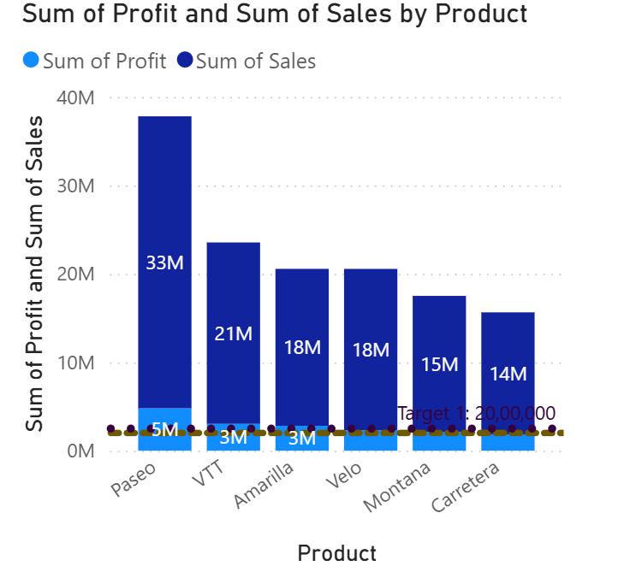

**CT- Stacked column chart**

**Insights:**

* Here we are creating the visuals for sum of profit and sum of sales by product.
* Here we can analyze Sales and profit both in one column.
* Paseo leads with the highest sold at 33M and 5M profit.
* Here we are created two targets between 2M to 2.5M.
* Paseo,VTT,Amarilla,Velo and montana reaches 2M target and Carretera didn’t reach target.
* Paseo, Vtt, Amarilla reached 2nd target 2.5M and rest of three product didn’t reach.
* Carretera didn’t reach any target and Velo, Montana reached at least one target.

**Steps to reproduce:**

1. Select Stacked column chart from build visuals.
2. Pass product to X-axis and Profit, sales to Y-axis.
3. Go to format your visual and turn on data labels.
4. Go to add further analyses to your visual.
5. Click on Y-axis constant line.

* Click on Add line
* Rename it as a target1
* Target value 2000000.
* Give dark Color for target line.
* Based on visual adjust Transparency for Target line.
* Click on Line style.

Options available are:

1. **Solid**
2. **Dashed**
3. **Dotted**
4. **Custom**

Format available in Custom line style.

Example: 5505,5005,5555

* Click on Scale by width

Based on Visual we can adjust Target line width.

* Position

Based on Visual we can use In front or back.

* Turn on Data label for target line value in visual.
* We can set data label where it perform (Right or Left)
* Vertical position Above or Bellow
* In style we can use Data Value, name and both.
* For Data value it will show only numeric value
* For name its shows title of target.
* for both it will show Target title as well as Data value also.
* Color: we can change any color of target line in visual.

1. Create one more target for 2.5M.

Click on Y-axis constant line.

* Click on Add line
* Rename it as a target1
* Target value 2000000.
* Give dark Color for target line.
* Based on visual adjust Transparency for Target line.
* Click on Line style.

Options available are:

1. **Solid**
2. **Dashed**
3. **Dotted**
4. **Custom**

Format available in Custom line style.

Example: 5505,5005,5555

* Click on Scale by width

Based on Visual we can adjust Target line width.

* Position

Based on Visual we can use In front or back.

* Turn on Data label for target line value in visual.
* We can set data label where it perform (Right or Left)
* Vertical position Above or Bellow
* In style we can use Data Value, name and both.
* For Data value it will show only numeric value.
* For name its shows title of target.
* for both it will show Target title as well as Data value also.
* Color: we can change any color of target line in visual.

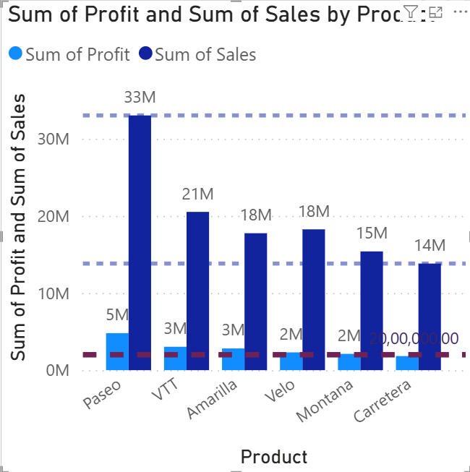

**CT- Clustered column chart**

**Insights:**

* Here we are creating the visuals for sum of profit and sum of sales by product.
* Here we can analyse Sale have one column and profit have one column.
* Both Profit and sales are started with Zero.
* In this visual easily we can find the value of Min,Max, Average and median throw line.
* We can create line for Sale and profit also.

**Steps to reproduce:**

1. Select Stacked column chart from build visuals.
2. Pass Product to X-axis and Pass Profit and sales to Y-axis.
3. Go to format your visual and turn on data labels.
4. Go to add further analyses to your visual.

* For target we have to create one line for target
* For that click on y-axis constant line and add line.
* Line> target value (2000000)> color.
* Transparency

Based on visual can change.

* Click on Line style.

Options available are:

* 1. **Solid**
  2. **Dashed**
  3. **Dotted**
  4. **Custom**

Format available in Custom line style.

Example: 5505,5005,5555

* Click on Scale by width

Based on Visual we can adjust Target line width.

* Position

Based on Visual we can use In front or back.

* Min line
* Add line and rename it as min line1
* Series ‘sum of sales’

Can give ‘Sum of profit also’

* Line

Select color, adjust transparency,Line style, Width and position

* Max line
* Add line and rename it as max line1
* Series ‘sum of sales’

Can give ‘Sum of profit also’

* Line
* Select color, adjust transparency,Line style, Width and position
* Average line
* Add line and rename it as max line1
* Series ‘sum of sales’

Can give ‘Sum of profit also’

* Line

Select color, adjust transparency,Line style, Width and position

* Median line
* Add line and rename it as max line1
* Series ‘sum of sales’

Can give ‘Sum of profit also’

* Line

Select color, adjust transparency,Line style, Width and position

Drill down and drill throw

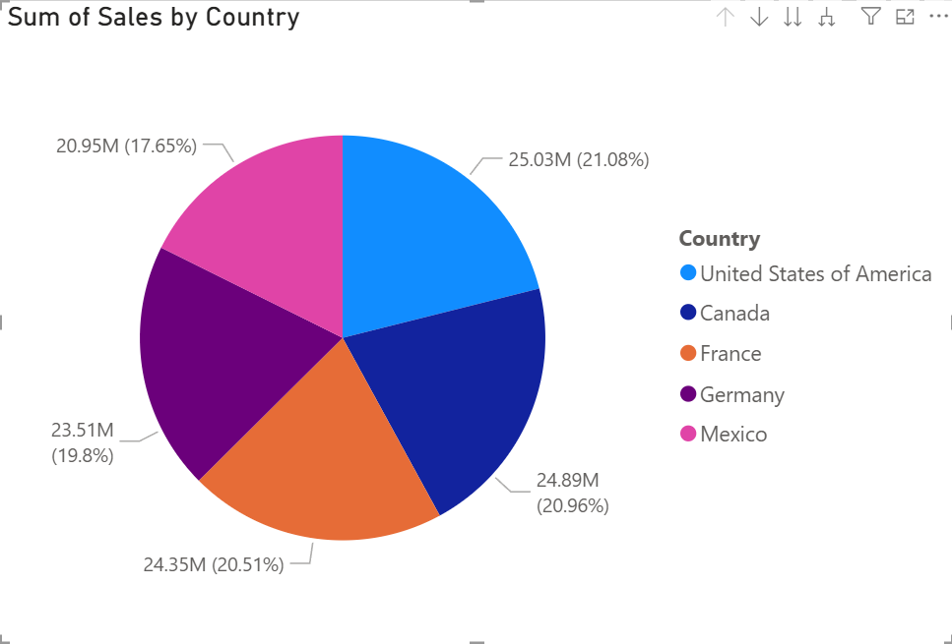 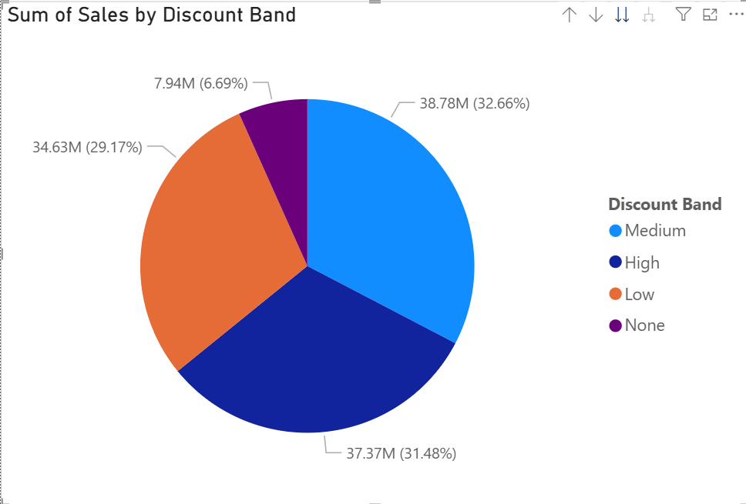

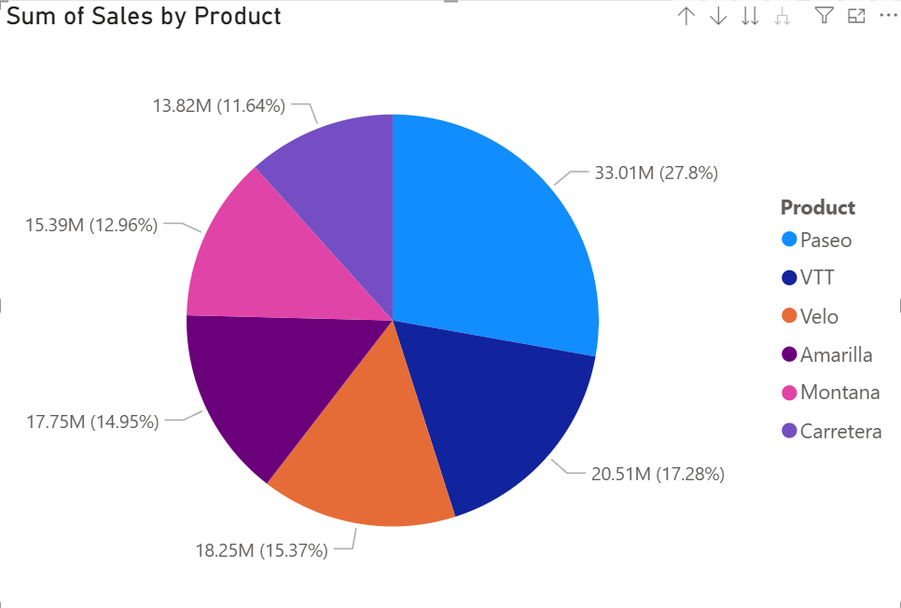 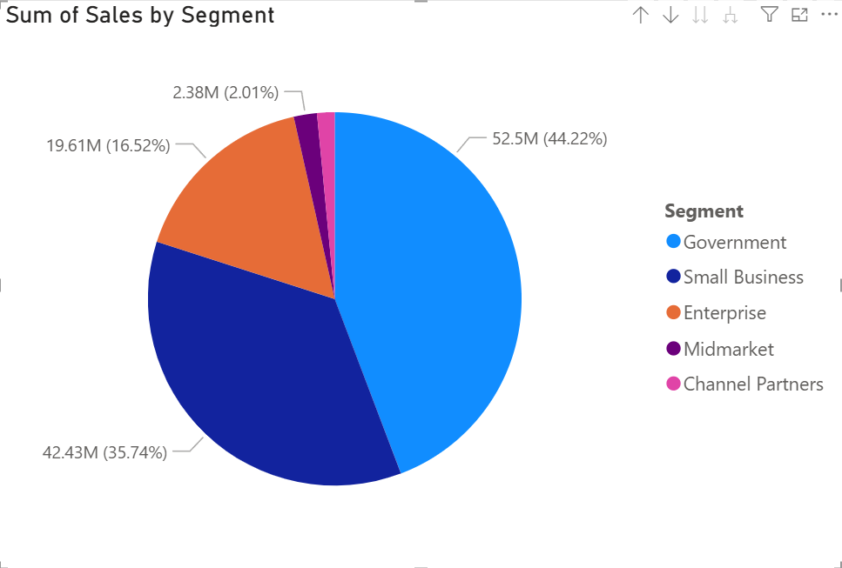

**CT-** **Pie chart**

**Insights:**

* Here we are creating visuals for Sum of sales by Country, Discount band, Product and segment in one pie chart
* For this report I have split every charts for better understand.
* Here we can absorb performance of sales in individual field.
* In this visual we can go particular country wise, particular Discount brand, particularProduct and particular Segment.

Example: Canada have 24.89M sales in that 8.66M have high discount band and Paseo Product have 2.74M and 1.78M Segment of Government.

* In this chart can insert multiple categories and we can drill it as user creation.

**Steps to reproduce:**

1. Select pie chart from Build visual.
2. Pass Country to legend and below add Discount band,Product and segment.
3. Pass sales to values.
4. Go to Format your visual.

* Turn on legends
* Turn on Details labels

1. In visual Top of right Some options available.
2. Drill up
3. Click to turn in Drill down
4. Go to the next level in the hierarchy
5. Expand all down one level in the hierarchy
6. Click on Drill down and click any Country.

* After click on country its shows selected country’s Discount band.

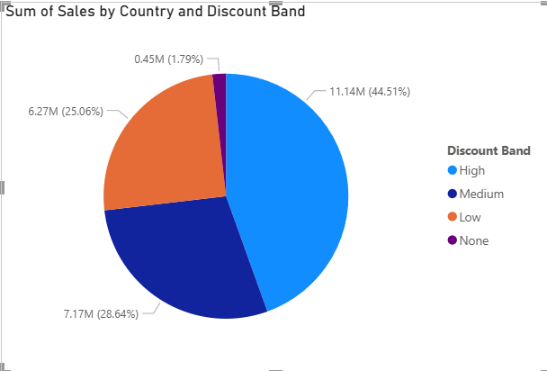

* If we select High in discount band than its show Selected country’s High discount brand product’s.

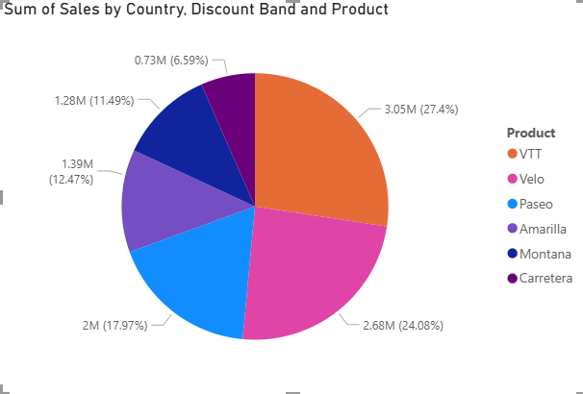

* In Product stage it shows types of product click any one of product its move to segment.

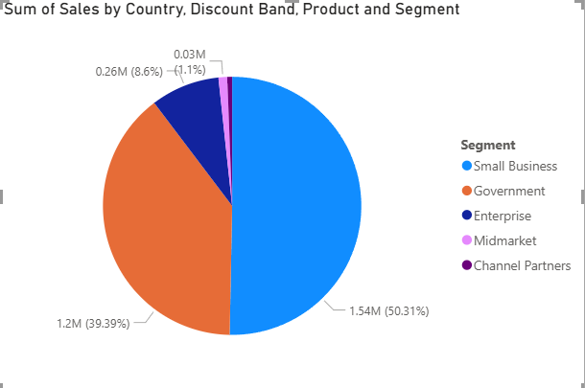

1. Click on go to the next level in the Hierarchy.

* Its move country to discount band.

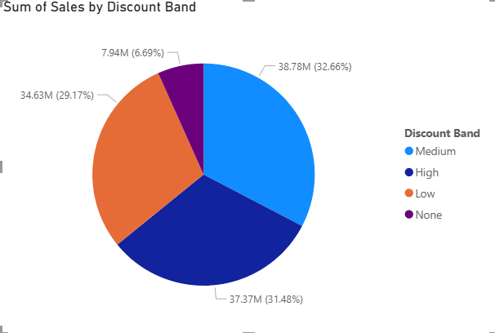

* Second click means its move Discount band to product.

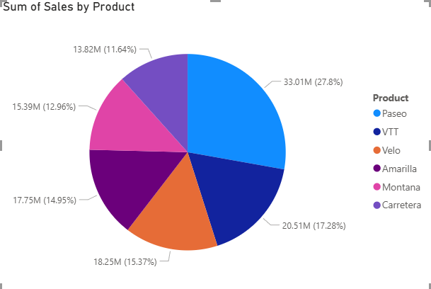

* Third click its move Segment pie chart.

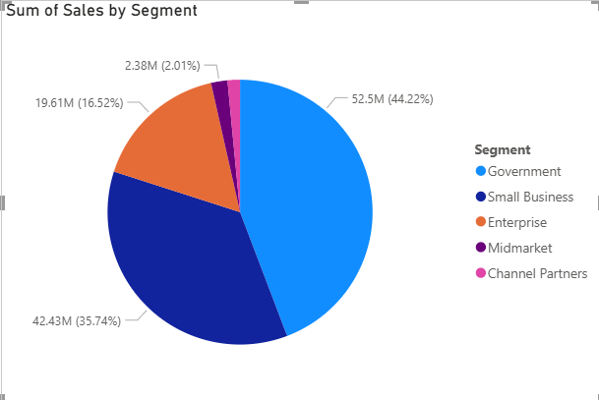

1. Click on Expand all down one level in the hierarchy.

* Its shows Sum of sales by country and Discount band in single pie chart.

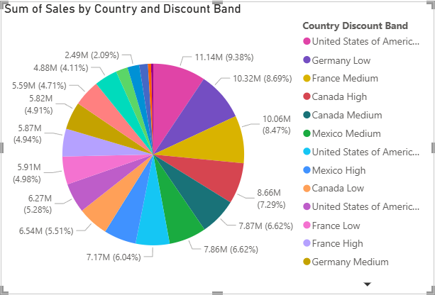

* Second click it’s add Product and

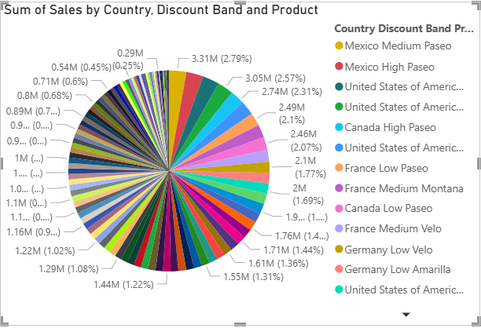

* For third click add Segment

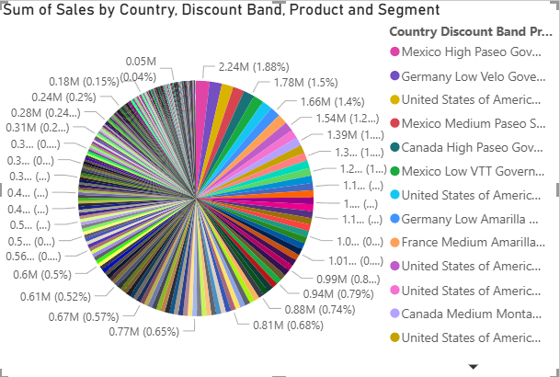

* In this option we can analyze multiple categories in one chart

1. If we have to come back after above mentioned options used means click drill up.